Welcome to our Cider Plant !
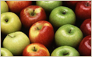
Cortesia Cider is one of the most prestigious establishments of the zone. Our experience and the process quality, are the reason our products have the highest international quality standard and one of the favorites of the country.

Our Products
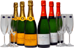
The excellence of our ciders is demonstrated in the variety of our production. The fresh and generous drink that goes with any food and any palate. We present our line to you > more information

Cider, ¿what do you know about cider? > more information
>> Recipes with Cortesia Cider<<

Distributors
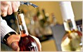
You too can categorize your business by being our distributor. Here are those who already have.
> more information

Get to know Mendoza
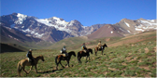
Because we are proud of our land, we want to invite you to know Mendoza.> more info here

Get to know our cider plant
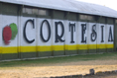
We show you our installations and technology. Here we tell you how are processes are from the harvest to the final packaging.
> more information
A little history
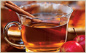
Since 1988 the company has developed having as its main goal to exceed its objectives.
> more information
News    Import and Export Analysis  > more information | Where are we    Tunuyan is located in Uco Valley, center-west of the Province of Mendoza in Argentina.  > more information

HOME: HOME
PRODUCTOS: PRODUCTS
BODEGA: PRODUCTION PLANT (O PLANT SOLO SI ES MUY LARGO)
HISTORIA: HISTORY
DISTRIBUIDORES: DISTRIBUTORS
CONTACTO: CONTACT

The Cider
“According to the Argentine Food Code, what is understood as the generic denomination of Cider or Genuine Cider, is the drink that is obtained by normal alcohol fermentation of fresh apple juice, industrially healthy and clear, with or without the addition of pears, in a proportion no superior than 10%”.

Its Name
The origin if the word cider, comes from the Greek “sikera”. In Latin is passes as sicera and in Asturian it begins to be pronounced as “sizra” and finally in Spanish “sidra”. In middle English it became “sidre”.

History
There are numerous texts throughout history that name cider and the orchards (apple tree plantations), but there is really no certifiable documentation about the origin of cider, except for the written by different authors, which assure that cider was already known by the Hebrew, the Egyptians and the Greek.
Plinio (23-79 d.c.) mentions drinks of pears and apples " e piris malorunque omnibus generibus ", cites apple wine and says that "… it’s the territory typical drink”
Estrabon, approximately 60 years before Christ, writes that the astures also use cider, since they have little wine "zytho etiam utuntur, vini parum habent"
Palladius shows us that in the 3rd Century the Romans prepared pear wines and even gives details of its production.

Cider in Argentina
In our country, the first cider production dates back to 1908 in the Parana Delta with apples of the region.
Until the year 1932 remote production tests were effectuated by the Island Plant, who was the first entity that produced cider in an industrial scale of acceptable quality.
In the country there are 15 producing companies. Seven industrial plants are located in Mendoza (Tunuyan), seven in the Alto Valley of Rio Negro and one in Calingasta, San Juan, being these the most popular industry production zones. (juice, fresh apples, cider).
Without entering in the description of the diverse apple varieties, it is enough to say that in practice they are divided into 3 categories:
- Sweet Apples
- Sour Apples
- Bitter Apples
To produce good cider, the sour apples are excluded and it is recommended not to introduce more than the eight of tenth part of these in the total weight of the fruit that is crushed
Regarding the others, they are mixed under variable conditions according to the perfume and bouquet they posses. Generally when it is desired that a cider is well preserved, it is necessary to increase the proportion of bitter apples, if it regards a sweet cider of immediate consumption, the quality of sweet apples in the mix can be elevated to 2/3. When the ripening is produced under unfavorable conditions, it is favorable to increase the proportion of bitter apples.

Physicochemical characteristics
Alcohol--------------------------------------- 4º to 7º GL
Total acidity ---------------------------------- 4,5 g/lts. of Tartaric ac.
Volatile acidity--------------------------------- up to 1 g/lts of Acetic acidity
Sugar: 80 grs per lt
Dry extract--------------------------------- superior to 16 g/lts
Ashes--------------------------------------- over 1,8 g/lts
Sulfur dioxide total ---------------------- up to 150 mg/lts
Sulfur dioxide free ---------------------- from 20 to 100 mg/lts
Sorbic acid (as sorbate) ------------------ 250 mg/lts
pH------------------------------------------- 3,1 a 3,9
Turbity: less than 1 U.T.N (nefelometric turbity unit)
CO₂ saturation: 4 atm (the same that a charmat method champagne would have)
Poliphenols total content > 1,5 gr. / l. expressed as tanic
Sweetening with sugar (sucrose) and corn syrup is allowed (JMAF).
Depending on the type of sweetener used:
Full = only sugar
Partial = sugar and corn syrup
TYPES OF CIDER
· gasified industrially with bulk CO2
· sparkling (champagne like)
• Cider: is the drink resultant from the total or partial alcoholic fermentation of fresh apples and its must.
The minimum alcohol content acquired must be 5% in volume.
It is denominated dry cider when it contains less than 30g/l of sugar; semidry between 30 and 50g/l and sweet when it contains from 50 g/l to its maximum limit which is 80 g/l.
• Natural Cider: : is the drink resultant from the total or partial alcoholic fermentation of fresh apples and its must, produced following the traditional methods, without sugar additives, it contains carbon gas originated from within.
The minimum alcohol content acquired is of 5% in volume.
Cider Production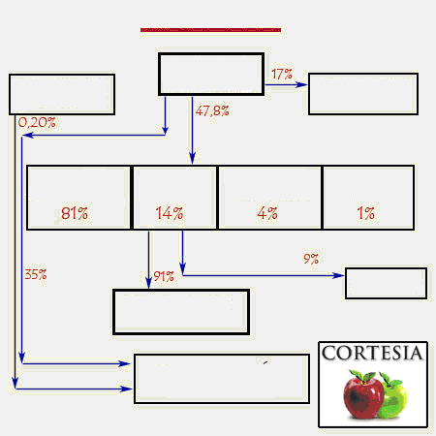
FOOD CHAIN
Fresh apple
exportation
Fresh apple
production
Fresh apple
importation
Pulp grinding
Dehyd.apple grinding
Cider grinding
Conc. Juice
grinding
Export
Cider consump.
3liters/hab/year

Fresh apple consump.
13 kgs/hab/year

HARVEST AND TRANSPORT
To obtain a maximum quality cider it is essential to begin with looking after the raw material, the apple; for this it is necessary to carry out a correct plantation applying the appropriate techniques. Another important aspect is the harvest; this must be done at the opportune time, previously effectuating the adequate quality and hygiene controls. The apple must be healthy, mature and with the right parameters.
The transport to the plant must be done as soon as possible, to avoid oxidations and over maturities. The process at the plant is the following:

Apple washing
Consists of eliminating the maximum quantity of strange substances (Earth, residues, vegetables, etc….), as also the possible germs that may be on the apples or the bodies before mentioned.
GRINDING
The grinding is done by means of a hammer mill, rolls and/or blades, adapting them always to the press requirements( fast extraction system, between 2 and 4 hours; or slow like in the classic systems that last three or four days) and the state of maturity (fruit hardness or swelling). This way, the raw material is grinded, turning it into a juicy paste that is pumped to short term storage tolvas. These tolvas full of apple paste are manipulated to dosify the paste for the presses. The juice extraction is done with semi-continue hydraulic presses. The yields in juice are of approximately between 70 and 75 lts per every 100 kgs of apples.
To avoid contaminations of metals such as copper, iron, etc…. in the must , the use of stainless steel is recommended , or the use of special paint used in the food industry.

MaceratiOn
Recommendable in mixes or acid varieties and in hard apples.

Pressing
If possible, all oxidations must be avoided during pressing. The must cloudiness levels must be controlled especially throughout the last presses. It is preferable to reduce the extraction yields to having to correct possible alterations derived from press contaminations.
Corrections with blends of different broths to maintain a protected pH, especially in the cases where the pH is higher than 3´5. As a rule, never exceed 1´5g/l of malic acid.
JUICE TREATMENTS BEFORE FERMENTATION
The juices obtained are sulphated with low dosis of SO2 (7 to 10 grs hl of SO2) which re trasvased to separate them from their sediments, in these conditions the selected yeast are placed to obtain better fermentations and of a higher quality in scent and taste.

Fermentation
The fermentation of the broth takes from 5 to 7 days, after which the first separation from the sediments is done and the anhydride sulphur is adjusted, with the purpose of starting the cleaning process.
Two phases must be seen here:
Tumultuous, in which the yeasts (Saccharomyces sp.) act on the must sugars transforming them into alcohol and CO2.
Slow or malolactic, the bacteria act in the malic acid generating lactic acid and CO2.
Generally The malolactic fermentation is produced once the tumultuous one is done, but there are cases in which the malolactic begins before the tumultuous is finished.
It is recommended a temperature of 15-17ºC is maintained during the tumultuous fermentation , and a temperature between 12-14ºC throughout the malolactic fermentation.
The recipient must be filled up to 85-90% during the tumultuous fermentation, and almost full during the malolactic fermentation. Avoid the overflow of the must “txapela“ during the fermentation.
Throughout the tumultuous daily controls of must density and temperature are carried out. The density value when out of the press is approximately 1045-1055 and this will decrease as the fermentation process progresses (tumultuous) down to 999-1001, indicating the final stage of this phase. During this phase the deposit will be kept with the lid over the top to avoid dust and drosophilae (fruits mosquitoes) from getting in, but not closed so that the CO2 generated can be evacuated.

DEPOSIT CLOSURE
The deposit will be closed at the density of 1002-1004, filling it completely with cider to avoid oxidations.

TRASVASING
Separation of the cider fermentation sediments. The purpose of this operation is to try and improve the microbiologic and chemical stability of the cider. It is done in those cases in which some kind of deviation is observed, be it in the analysis or tasting, taking into account that it must always be done airtight, at low temperature and if possible when the atmospheric pressure is high.
CLARIFICATION AND FILTRATION
The clarification consists of carrying out two or three transvases, and then by means of special clarifiers, (Bentonite, jelly, etc.) a more effective clarity is achieved. Under these conditions, a final and more profound clearing is done by means of diatomaceous earth filters.

BOTTLING
This will be done when the cider is below 1000 density value and if the aromatic and taste qualities required of the natural quality cider are found. As for its execution, the same transvasing criteria will be followed, especially avoided oxidations and stirring the cider the least possible.
It is recommended that the following are added:
10 gr. / hl. de acid ascorbic
8 gr. / hl. de potassium met bisulphate.

POURING
This is done so that the oxygen in the air mixes with the carbonic that the cider has. This way, the organoleptic properties, acquire relevant and significance.
A little pungency is what the cider acquires when it is poured.
The cider needs to air before being consumed and due to this is that it needs to be poured from high, it is not just something merely esthetic. Though in the past the height wasn’t so much due to the reduced size of glasses, today with the current glasses, which are of thin glass and with a height of approximately 12 cm, with 9 cm rim and 7 cm base, the pouring height has increase up to a level over the head, up to where the arm reaches.
Decalogue of cider serving:
1º The posture must be straight, without being rigid.
2ºThe arm that holds the bottle, stretched above the head.
3º The arm that holds the glass stretched down low and toward the center of the body.
4º Once the bottle has been tilted to pour the liquid, it is held with the index finger, the middle and ring fingers over the body part and the thumb and little one on the base.
5º The fingers that hold the bottle must not go beyond the same towards the rim direction.
6º The glass is held with the index thumb and index finger on the base of the glass and the ring finger together with the little one held in the palm of the hand.
7º The glass must not move from the center of the body, which means that the cider bottle should look for the glass.
8º The cork can be held with the ring and little fingers of the hand in charge of holding the glass.
9º When serving the glass of cider, if the thumb is retrieved from the glass it makes picking it up easier.
10º The pourer must always make sure the cider froths.

Cider care
It is similar to that of the wine.
Avoid shaking the cider.
The cider must be cool not cold, the ideal cider temperature is between the 12-14˚C, it is therefore convenient to keep it in cool water and always avoiding that the Cork goes into contact with the water.
The cider must not be aged.
CIDER DEFECTS
The natural cider is a living element that is subject to interact with diverse microorganisms, normally lactic bacteria can produce alterations in the cider quality. This can happen due to undesired reactions or wrong oenological practices produced throughout the production process. The most common are:
Acetified. High levels of volatile acidity generated normally by action of lactic bacteria. To avoid this it is necessary to keep the PH levels low.
Oily. The activation of certain lactic bacteria generates polysaccharides that infer the cider a slimy character.
Fruited. In accordance to the studies carried out up until the moment it is estimated that this alteration is due to n increase of acrolein generated by lactic bacteria.
Turbity: In addition to the loss of sparkle due to diverse colloidal phenomena, this can also be produced due to the excessive use of pears, because of its fibrous texture.
Potassium sorbate: This defect occurs when its use (of permissible limits) is abusive, capturing some spicy and aggressive notes.
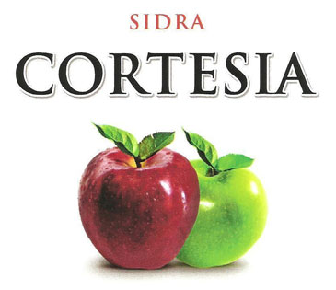
> Recipes with cider <
> Economic analysis of the cider production in Argentina <

Where we are ::: The production plant ::: Our products ::: News ::: Get to know Mendoza ::: Contact us

Production plant: Route 40 Km 77. Tunuyan. Mendoza. Argentina
Information and sales click here
Distributors
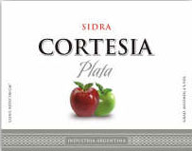
Would you like to be a distributor of our products? There are still areas available for Argentina. Fill in the following application and we will contact you.
Principio del formulario
Complete name: | 
City:
Province/State:
Email:
Telephone:
Comments:
 (Send)
Final del formulario
Where we are ::: The production plant ::: Our products ::: News ::: Get to know Mendoza ::: Contact us
Production plant: Route 40 Km 77. Tunuyan. Mendoza. Argentina
Information and sales click here
Get to know our production plant
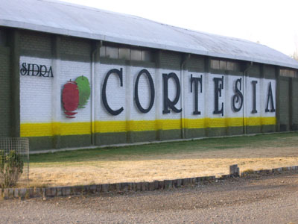
We show you our facilities and technology. We tell you how our processes are done from the harvest to the final packaging.

[ Web site under construction ]
Where are we ::: The production plant ::: Our products ::: News ::: Get to know Mendoza ::: Contact us

Production plant: Route 40 Km 77. Tunuyan. Mendoza. Argentina
Information and sales click here

A little history
Our company was born in 1988 and its aim is to surpass its own objectives. The main ones were the quality of its products and the union of its human resources, objective that has been achieved in its young 20 years of existence.
We are convinced that by being genuine and maintaining the quality of our products is what has allowed us to obtain the recognition and satisfaction of our clients.
The products of Cortesia Cider are produced using a variety of apple that is traditional of the Uco Valley area, mainly Red Delicious and Granny Smith. We also produce fruit products such as: Pineapple and Strawberry fizz, as also Non-Alcoholic cider where excellent quality cider is combined with premium natural juices and pulps.
Cortesia Cider is the only company that carries out all of the production stages and fractioning at the same place where it is located, having as an objective its spirit of enhancing a natural and genuine product that highlight the virtues of the area. The company counts with 15 Has. of orchards that are taken care of intensively
Where we are ::: The production plant ::: Our products ::: News ::: Get to know Mendoza ::: Contact us

Production plant: Route 40 Km 77. Tunuyan. Mendoza. Argentina
Information and sales click here

¿Where are we?
Sidra Cortesia is located on Route Nº 40 Km 77, in the Department of Tunuyan, Mendoza Province of Argentina- Geographically it is surrounded by the Uco Valley and the “Cordon del Plata” , which belongs to the Andes Mountain Range.

Our Products
Cortesia Cider
Pet 1500 cc
Delicate flavor and intense fruit scent of the Premium quality raw material used, fresh and elegant, with a distinguished pungency.
>See technical information

Cortesia Cider
Pet 910 cc
Soft yellow colors with green tones.

>See technical information

Cortesia Silver Cider
Produced with the best selection of Red Delicious, Granny Smith and Royal Gala varieties.
>See technical information

Cortesia Fruit Cider
Pineapple Fizz
Exquisite flavor with an intense pineapple aroma..

>See technical information

Cortesia Fruit Cider
Strawberry Fizz
Exquisite flavor with intense aroma of fresh strawberries.

>See technical information

Cortesia Cider
Non- alcoholic
Soft Bellow colors with green tones and a delicate flavor y and fruit scent.
>See technical information

Cider and Health
The consumption of quality cider grants purifying, detoxifying and anti – inflammatory properties. It has direct action upon the digestive system achieving a balance in the metabolism, improving diuresis, increasing the permeability of the small blood vessels producing a pleasant and relaxing sensation.
The consumption of cider prior to foods produces a satiety effect which decreases the posterior ingestion. It is a product achieved from the fermentation process carried out by a microorganism called yeast that acts on the apple sugar giving as a result a product with low alcohol grade ( 4% to 5% of alcohol). Know more about this refreshing beverage here.

> Recipes with Cortesia Cider<
Do you wish to learn more about cider?
Economic analysis of cider production in Argentina <

La sidra y la cocina: The cider and the kitchen
Volver: Back
Ver mapa: See map

